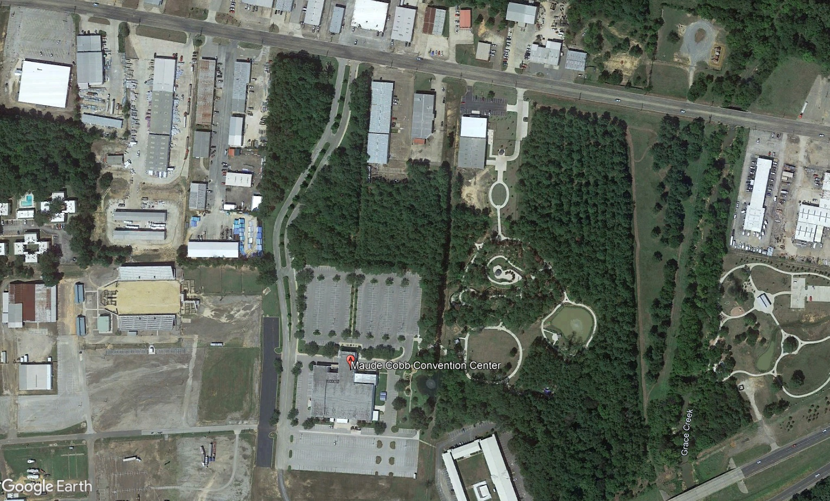
GTBR pilot logger return, all pilot unused marker return
Pilot Entrance
Pilot Parking

Address: 100 Grand Blvd. Longview Texas
Coordinates: 15 S334721.53 E / 3596510.23 N

